|  |  |
| --- | --- |
| **Operating Systems and Networking Fundamentals**  Diploma in CSF/IT  Year 1 (2021/22) Semester 2 | Week 12 |
| Practical |
| **Setting Up a Simple Switched Network** | |

OBJECTIVES

* Learn to use ipconfig and ping commands to examine the IP address and test network connectivity;
* Share resources between computers in a simple switched network;
* Setup a simple local area network (LAN) with a switch.

Resources:

* 2 Desktop PCs
* 1 Ethernet Switch
* 2 UTP cables

#### ACTIVITY 1 : Examining the PC’s IP Address and Testing Connectivity

*\*\*Note:*

* *Divide the tutorial class into* ***6 to 8 teams****. Each team is assigned a team number, 1 to 8.*
* *This activity is based on Windows 10 Operating System (select the correct option when booting up).*

1. PCs on the network are installed with the TCP/IP as part of the Windows Operating System (OS) to allow them to communicate with each other. TCP/IP Version 4 (IPv4) and version 6 (IPv6) are supported.
2. We shall make use of a TCP/IP utility to help us determine whether there is connectivity between PCs, i.e. the **“ping”** utility. Internet Protocol (IP) allows us to use an “IP address” to uniquely identify a computer in the network.

a) **Examine the IP address of your PC:**

Start the Command Prompt window (search for **Command Prompt** and selecting it).

In the Command prompt window, type in the command: **ipconfig**

You should see the IPv4 Address (e.g. 153.20.57.123) assigned to your computer as part of the response.

b) **Test the connectivity of your PC to another PC:**

In the Command prompt window, type in the command: **ping 153.20.57.xxx** where 153.20.57.xxx is the IP address of the destination PC you try to communicate with.

If you get a reply stating that:

Packets: Sent = 4, Received = 4, Lost = 0 (0% loss),

you can be sure that there is connectivity between the two PCs across the network.

**Note: If you do not receive the above, check the IP address and try again. [Ensure that the PCs are connected to the network; and Windows Firewall / Antivirus Protection is turned off]**

#### ACTIVITY 2 : Sharing Resources in a Simple Switched Network

1. A simple switched network is installed in the lab i.e. the PCs on the network are set up to communicate with each other as equals. Each PC is responsible for making its resources available to other computers on the network.

1. In this practical exercise you will configure the PCs so that they can share resources e.g. folders and files with each other.

You will use **workgroup** feature provided by Windows OS to share files. The following should have been installed/configured:

- TCP/IP is installed and configured

- Client for Microsoft Networks is installed

- File and Printer Sharing for Microsoft Network installed

[Note: you can check the networking software components by searching for **View** **Network Connections**, right-clicking on **Ethernet** and selecting **Properties**]

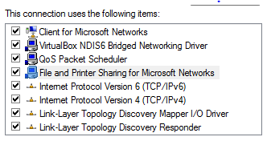

3. Search for **System** and then click **System**.

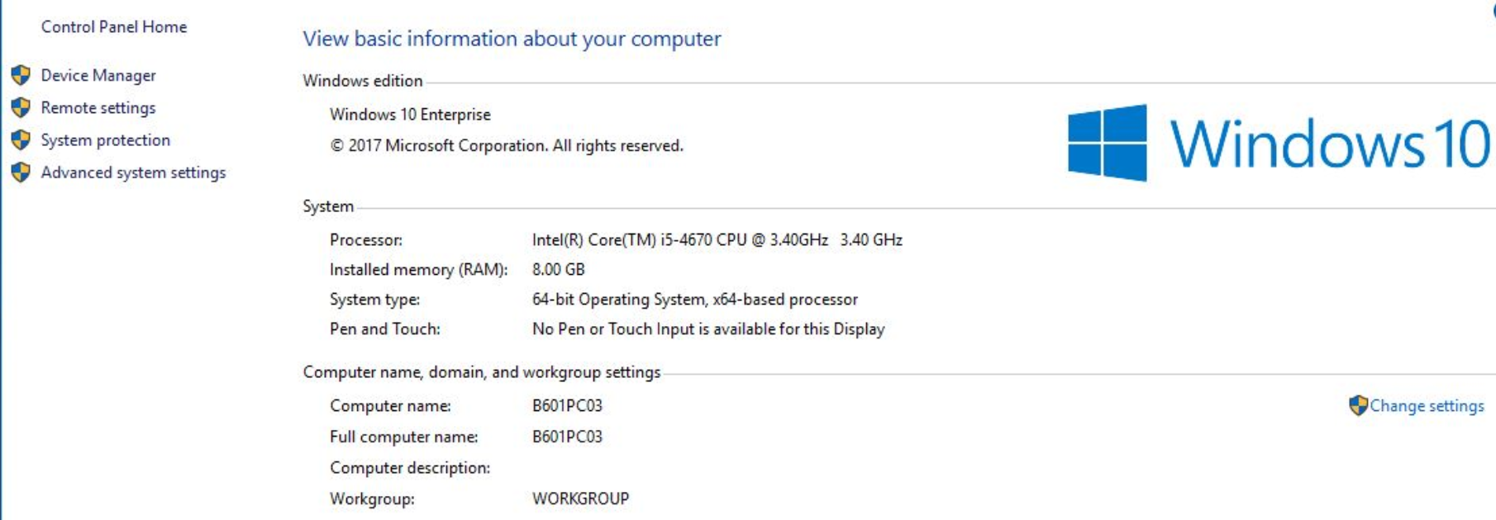

4. In the System Properties dialog box, what is your current computer name and workgroup name?

|  |
| --- |
| Computer name: LAPTOP-P46Q4VS1  Workgroup: WORKGROUP |

PCs in a peer-to-peer network must be configured with the **same Workgroup name**.

Note: You may click the **Change** button to change the computer name and workgroup name. **For this lab exercise, do not change!!**

5. To view the members (PCs / computers) in your workgroup, Click on **File Explorer** and then click on **Network** in the left pane of the **This PC** Window.

The PC will start searching for other computers in the with workgroup name: “WORKGROUP”.

If the Network discovery and file sharing are turned off, turn them on.

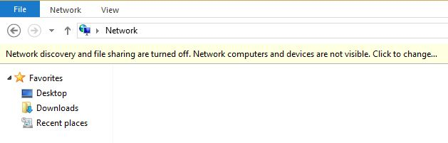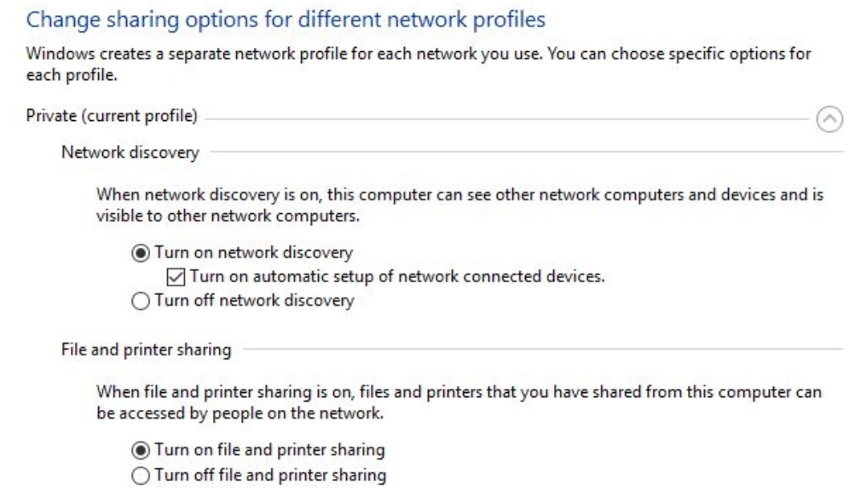

You can change the sharing options in **Network and Sharing Centre** and select **Change Advanced Sharing Setting**.

6. **Create a shared folder** in your PC and display on the right pane.

1. In Windows Explorer, right-click on the Desktop and create a new folder called myname (where myname is your actual name, e.g. John):
   * Right-click the myname folder and select **Properties**
   * Click on **Sharing** tab and click on **Advanced Sharing**
   * In the Advanced Sharing dialogue box, tick on **Share this folder**
   * Click **Apply**
2. Create a new text document in this shared folder using Word or Notepad.

The shared folder is ready for access by other PCs in the workgroup.

7. To access the shared folder called myname, from another PC, do this:

1. Launch **File Explorer** and then click on **Network** in the left pane
2. A list of computers in the workgroup is displayed.
3. Double click on the computer which the shared folder is created.
4. You should be able to view the shared folder.
5. Click on the shared folder that contains the text document created.

[If you do not have permission to view the file in the shared folder, you need to get your team mate to configure the sharing of folder with specific people in step 8]

[If Network Discovery did not work, type \\computer_name\share_name into the File Explorer search bar]

8. You can **share the shared folder** in your PC with specific people.

1. Right-click the myname folder and select **Properties**
2. Click on **Sharing** tab and click on **Share …**
3. Click on the drop-down list and select **Everyone**
4. Click **Add,** click **Share** and click **Done**

#### ACTIVITY 3 : Setting up a Local Area Network (LAN)

*\*\*Note: Each team is given a network switch.*

Each team constructs a simple Local Area Network (LAN) by connecting up 2 PCs and a laptop (optional) to a Switch.

1. Fill in the blanks:

1. ______Switch________ - A network device acting as a central connecting point to all the PCs and laptop.
2. The cable used is called a/an _____UTP____________________________ cable.
3. Cable connectors – Each cable is terminated on its two ends by a ____RJ45____ connector. Notice that each connector has __8____ pins crimped onto ___4___ pairs of colored wires.
4. Each PC needs to have a ________________Network interface controller____ (or equivalent built-in circuitry on motherboard) for LAN communication.
5. On one of the broader side of a connector is a little springy plastic tab that locks the connector to a socket (also called a port) on a network interface card (NIC). To remove the connector from the socket the tab has to be _______pressed down____ while being pulled from its port. (Note: This tab is quite fragile, so treat it with care)

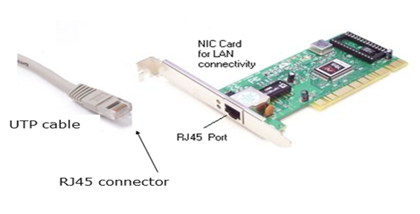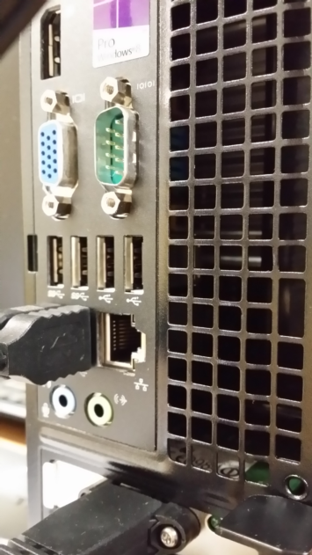

* 1. In Figure 1 below:

1. Label the network device and the port.
2. Draw a line from each PC to a port in the equipment to represent the UTP cable connection.
3. Identify the physical topology of this network setup: _________LAN________

|  |
| --- |
| PC 2  PC 1  Network Device: switch__  Name of Port: rj45 port__  Laptop 2  Laptop 1 |

**Figure 1**

3. Connect the PCs/Laptops to the switch using UTP cables. i.e. plug one end of an UTP cable into the RJ45 port of the switch, and plug the other end of the cable into the RJ45 port of the PC. Power-up the switch and power-on the PCs. You have in fact set up a **Local Area Network (LAN)**.

4. This LAN uses Ethernet technology and is called an **Ethernet LAN**. The NIC for each PC contains the program logic for a PC to communicate with another PC across the cables in the network. The switch also uses Ethernet technology; hence it is called an **Ethernet Switch**.

5. **Examine the port LED indicators on the Switch and PC**.

Are they flickering?

What can you deduce from these LED indicators?

|  |
| --- |
| The LED indicators on the switch are flickering which means there is data flow from the PC’s going in or out of the switch |

6. Configure IP Address for PCs:

a) **Examine the IP address of your PC:**

Start the Command Prompt window by right-clicking on the Start button.

In the Command prompt window, type in the command: **ipconfig**

You should see the IP address assigned to your computer as part of the response.

b) You may see an **address: 169.254.x.x**, a range of IP addresses reserved for Automatic Private IP Addressing (APIPA). If the PC is set to automatically obtain an IP and receive one of these addresses, Windows has assigned this because it cannot find a DHCP server within the network subnet.

You can assign an IP address to the PC manually:

* + - Right click on the Network icon at the bottom right corner of the screen. Select **Open Network and Sharing Center.** Click **Change adapter settings** (top left corner).
    - Right click on the Ethernet Connection icon in the Network Connections panel. Click Properties. The Ethernet Properties are displayed in Figure 2.

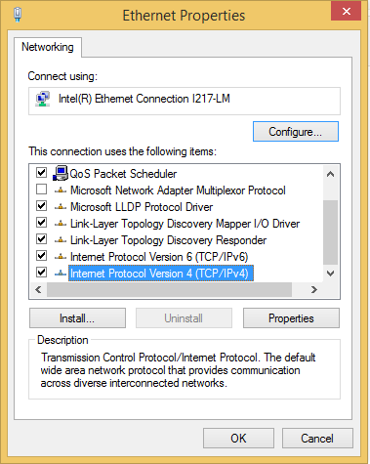

**Figure 2**

* + - Select Internet Protocol Version 4 (TCP/IPv4), click Properties. The IPv4 Properties are displayed in Figure 3.

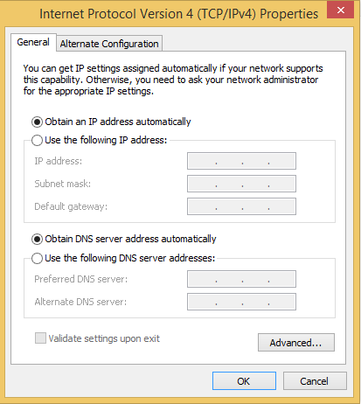

Select the “**Use the following IP address**” button. Enter the settings as follows:

**IP address**: 10.0.A.B

(A is the Team number,

B is a unique number within the team).

**Subnet mask**: 255.0.0.0

**Default gateway**: *<blank>*

Click OK.

(Note: IP address etc will be covered in later chapter)

**Figure 3**

7. Once all the PCs have the IP addresses assigned, we can test for connectivity between the PCs in the LAN.

In the DOS prompt window, type in this command:

**ping 10.0.xxx.xxx**

where 10.0.xxx.xxx is the IP address of the PC you try to communicate with.

If you get a reply stating that:

Packets: Sent = 4, Received = 4, Lost = 0 (0% loss),

you can be sure that there is connectivity between the two PCs across the LAN.

**Note: If you do not receive the above, check your IP address and subnet mask settings and try again.**

**ACTIVITY 4 : Expanding the Network**

1. Connect the switches of two teams with a UTP cable using any of their unused ports as shown in Figure below. Do not change the network configurations of the PCs.

**LAN Switch**

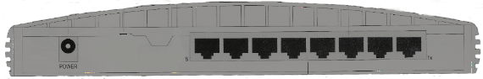

**PC3**

IP Address: 10.0.Y.1

Netmask: 255.0.0.0

**PC4**

IP Address: 10.0.Y.2

Netmask: 255.0.0.0

**Switch ports**



**PC1**

IP Address: 10.0.X.1

Netmask: 255.0.0.0

**PC2**

IP Address: 10.0.X.2

Netmask: 255.0.0.0

**Switch ports**

1. Suggest two reasons for switches to be connected in this way (cascading of switches) to expand the network.

|  |
| --- |
|  |

b) From each PC, you should be able to ping 2 additional PCs in the expanded network.

**ACTIVITY 5 : Restoring the PCs’ Setting and Connection**

1. Reset all the PCs to its original IPv4 setting.



2. Connect all the PCs to the NP Network. Ensure that the PCs are able to browse the Internet. [If you face any problems, seek assistance from your tutor]

* 1. Remove the shared folder you have created on your PC.

--- End ---